PRAXIS SOCIAL ANALYSIS TOOL

SUSTAINABLE LIVES AND LIVELIHOOD FRAMEWORK

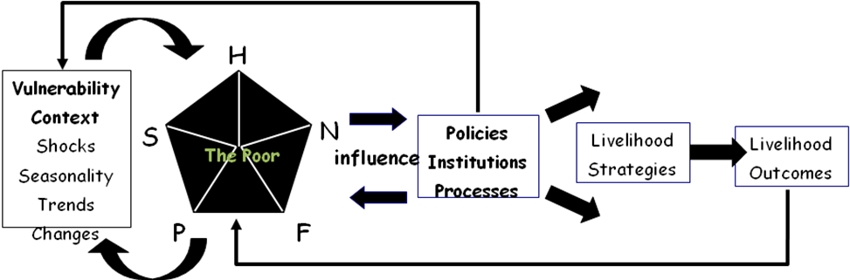
- TABLE
RESOURCES | OBSERVATIONS
HUMAN | ■ What is the composition of the household? (How many people live in a household? What are the common age groups (mostly adult or mostly minors)? What are the different religions present (what is the dominant religion in the household/community)? What are the roles in the different livelihood activities? What is the household residency status in the community (temporary or permanent)  ■ How does household composition vary by socio-economic status?  ■ What is the educational status of resident and non-resident household members?  ■ What skills, capacity, knowledge and experience do different household members have?  ■ How do education, skills and physical labor capacity vary by socio-economic status?
NATURAL | ■ What land, water, livestock, and plant or forest resources do household members use inside and outside the village? What do they use them for?  ■ What are the terms of access and exchange of these natural resources (ownership, rental, share arrangements, open-access, passage, leasing)
PHYSICAL | ■ What infrastructure do household members have access to and use (transport, marketing facilities, health services, educational facilities, water supply)? What infrastructures do they can’t have access to?  ■ What are the terms of access to and maintenance of different types of infrastructure (payment, open access, individual or “pooled”, etc.)?  ■ What tools or equipment do household members use during different livelihood activities and what are the terms of access to them (ownership, hire, sharing, etc.)? How and by whom are they maintained?
FINANCIAL | ■ What are the earnings of the household from different sources (crop & livestock sales, processing, off-farm activities, business, forest products, fishing, remittances, gifts)?  ■ What other sources of finance are available and how important are they (bank credit, moneylenders)?  - How or what are their expenditures?
SOCIAL | ■ What links does the household have with other households or individuals in the community (kinship, social group, and membership in social, economic and religious organizations, political contacts, patronage)?  ■ In what situations do those links become important and how (mutual assistance, pooling labor)?
VULNERABILITY CONTEXT | ■ What are the seasonal patterns of different activities that household members engage in?  ■ What seasonal patterns can be observed in terms of food supply, income, expenditure, residence, etc.?  ■ What crises has the household faced in the past (health crises, natural disasters, crop failures, civil unrest, legal problems, indebtedness, etc.) and how did they deal with them?  ■ What longer-term changes took place in the household’s natural, economic and social environment? How did it deal with these changes?
POLICIES, INSTITUTIONS AND PROCESSES | ■ What organizations, institutions and associations (societies, cooperatives, political parties, etc.) do household members participate in and what role(s) do they play in them?  ■ How are decisions reached within these organizations, institutions and associations?  ■ Who makes decisions about the use of natural and physical resources in the community? How those decisions were reached (what are the centers of decision-making)?  ■ What laws, rules and regulations affect the household?  ■ Which organizations are most important for the household and what benefit do they bring?
- ANALYSIS
  - Characteristics of typical non-poor, middle and poor households
    - Land (typical farm size, irrigated – non-irrigated)
    - Livestock (typical holding by species)
    - Physical assets (equipment, housing, shops)
    - Financial capital (savings/indebtedness, trading capital, remittances, pensions, credit)
    - Human capital (household size, labour force, health status, education and skills, migration)
    - Social memberships, connections and influence
    - How do assets vary between non-poor and poor?
  - How does the historical, political and institutional context influence household resources?
    - Influence of history, politics and institutions on access to land, water and natural resources
    - Influence of socio-historical factors on physical, financial, human and social capital
    - Influence of the socio-historical context on household composition and demographic trends (settlement, migration, seasonal and long term population movements, etc.)
  - How do resources affect livelihood options of different categories of households?
    - Do wealthy households have wider livelihood options? Do poor households have narrower options?
    - How does gender affect livelihood options?
    - How do age and ethnicity affect livelihood options?
  - What are the main livelihood sources and strategies of different categories of households?
    - Total pattern of activities of a typical non-poor household, poor household, very poor
    - Typical livelihood activities of women and men in each socio-economic category
    - How do different categories of households reduce their vulnerability to shocks?
    - Are both non-poor and poor exposed to the same outside shocks?
    - If so, what enables the non-poor to keep from falling into poverty in the face of shocks?
  - What are the trends in living standards of poor and non-poor households?
    - What are the main shocks affecting livelihoods? Do they affect poor and non-poor differently?
    - What resources enable the non-poor to withstand shocks better than the poor?
    - What role do local institutions play in households’ ability to withstand shocks?
    - Which categories of people are improving their living standards and which are eroding?
    - Upward and downward social mobility (of households over the life cycle and of whole categories of people relative to their neighbors): who is falling into poverty? Who is getting out of poverty?
    - Who are the winners and losers?
    - Who is building up their capital assets and who is depleting them and why?
    - Who were the poor and non poor two generations ago and who are likely to be the poor two generations from now? Why?
  - What are the causes of differences in wealth and poverty?
    - Rich or poor parents?
    - How much is explained by vulnerability to outside shocks?
    - How much is explained by institutions that favor rich / powerful and discriminate against the weak?
    - To what extent are “successful” livelihood strategies explained by personal virtues such as hard work and cleverness as opposed to having the right social background and assets?
    - To what extent are “unsuccessful” livelihood strategies explained by bad luck or lack of resources as opposed to personal shortcomings of household members

- LIFE AND LIVELIHOOD STRATEGIES
Considering the current assets accessible to the community, policies, institutions and processes that support or hinder the community, and taking into account the community’s vulnerability, what are the possible recommendations on their life and/or livelihood strategies that can be adopted by the community?
As students what can be your participation in these recommendations that you or the community proposed?
RECOMMENDATIONS | POSSIBLE LIFE OUTCOMES | STUDENTS’ PARTICIPATION
1.
2.

Note: This social analysis tool was based on:
- Rapid Guide for Missions (Analysing Local Institutions and Livelihoods) by Alice Stewart Carloni
- Lecture/input from Mr. Leland dela Cruz

